PLANNED GIFTS
Revocable Living Trust

Individuals Use Revocable Living Trusts (RLT) to:
- Avoid probate, publicity and expense.
- Retain rights to the trust property during life.
- Ensure property is properly managed in the event the trustee becomes incapacitated.
- Ensure asset distribution according to their wishes.

In an RLT, you retain control of the assets held in the trust during your lifetime. At death, the assets usually avoid probate and the trust terms direct the distribution of the assets to beneficiaries, including charitable organizations like Interfaith Ministries for Greater Houston (IM).

How it Works:
During your lifetime, you typically serve as the trustee and can alter or revoke the trust and may add or remove assets. You also name
a successor trustee, as well as the beneficiaries, including charities, who will receive any assets that remain in the trust at your death. At your death, the trust becomes irrevocable or terminates.

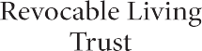
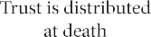
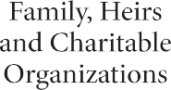
Why is an RLT Useful?
- Provides flexibility by adding or removing estate assets or changing trust terms as needed prior to death.
- Avoids probate in most cases.
- Controls assets after death through the terms of the trust.

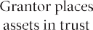

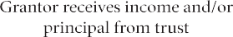

For more information, contact mmagee@imgh.org or 713-533-4924.
The information contained herein is offered for general informational and educational purposes. You should seek the advice of a financial planner for applicability to your own situation.

