PLANNED GIFTS
Life Insurance

Individuals Donate Life Insurance to:
- Have the ability to make a substantial gift for a relatively modest annual expense.
- Retain ownership of the policy or permanently assign the policy to Interfaith Ministries for Greater Houston (IM).
- Make IM the entire beneficiary, partial beneficiary or recipient of dividends.

Life insurance can be an excellent tool for charitable giving. Not only does life insurance allow you to make a substantial gift to charity at relatively little cost to you, but you may also benefit from tax rules that apply to gifts of life insurance.

How it Works:
- Name IM as beneficiary of a policy (revocable).
- Purchase a policy, give it to IM and continue to make premium payments (irrevocable).
- During your lifetime, donate life insurance dividends to IM.

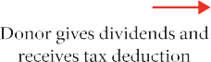More to Know:
- It provides a substantial gift (face value of the policy) to IM and is simple to accomplish.
- There is no immediate tax deduction for naming IM as beneficiary, but you receive a charitable deduction from your estate upon death.
- There are income tax savings if the policy is donated to IM, including a charitable deduction for policy premium payments and/or cash value.
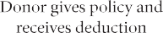
- Asset/wealth replacement is possible through a more sophisticated use of life insurance.

IM receives cash value or proceeds at your death

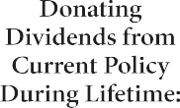

For more information, contact mmagee@imgh.org or 713-533-4924.

The information contained herein is offered for general informational and educational purposes. You should seek the advice of a financial planner for applicability to your own situation.

